|  |
| --- |
| Release 1 |
| Personal Portfolio |
| IFB299 |

|  |
| --- |
| Nathan Norris  08847487 |

## Artefact 1

**Peer Review**

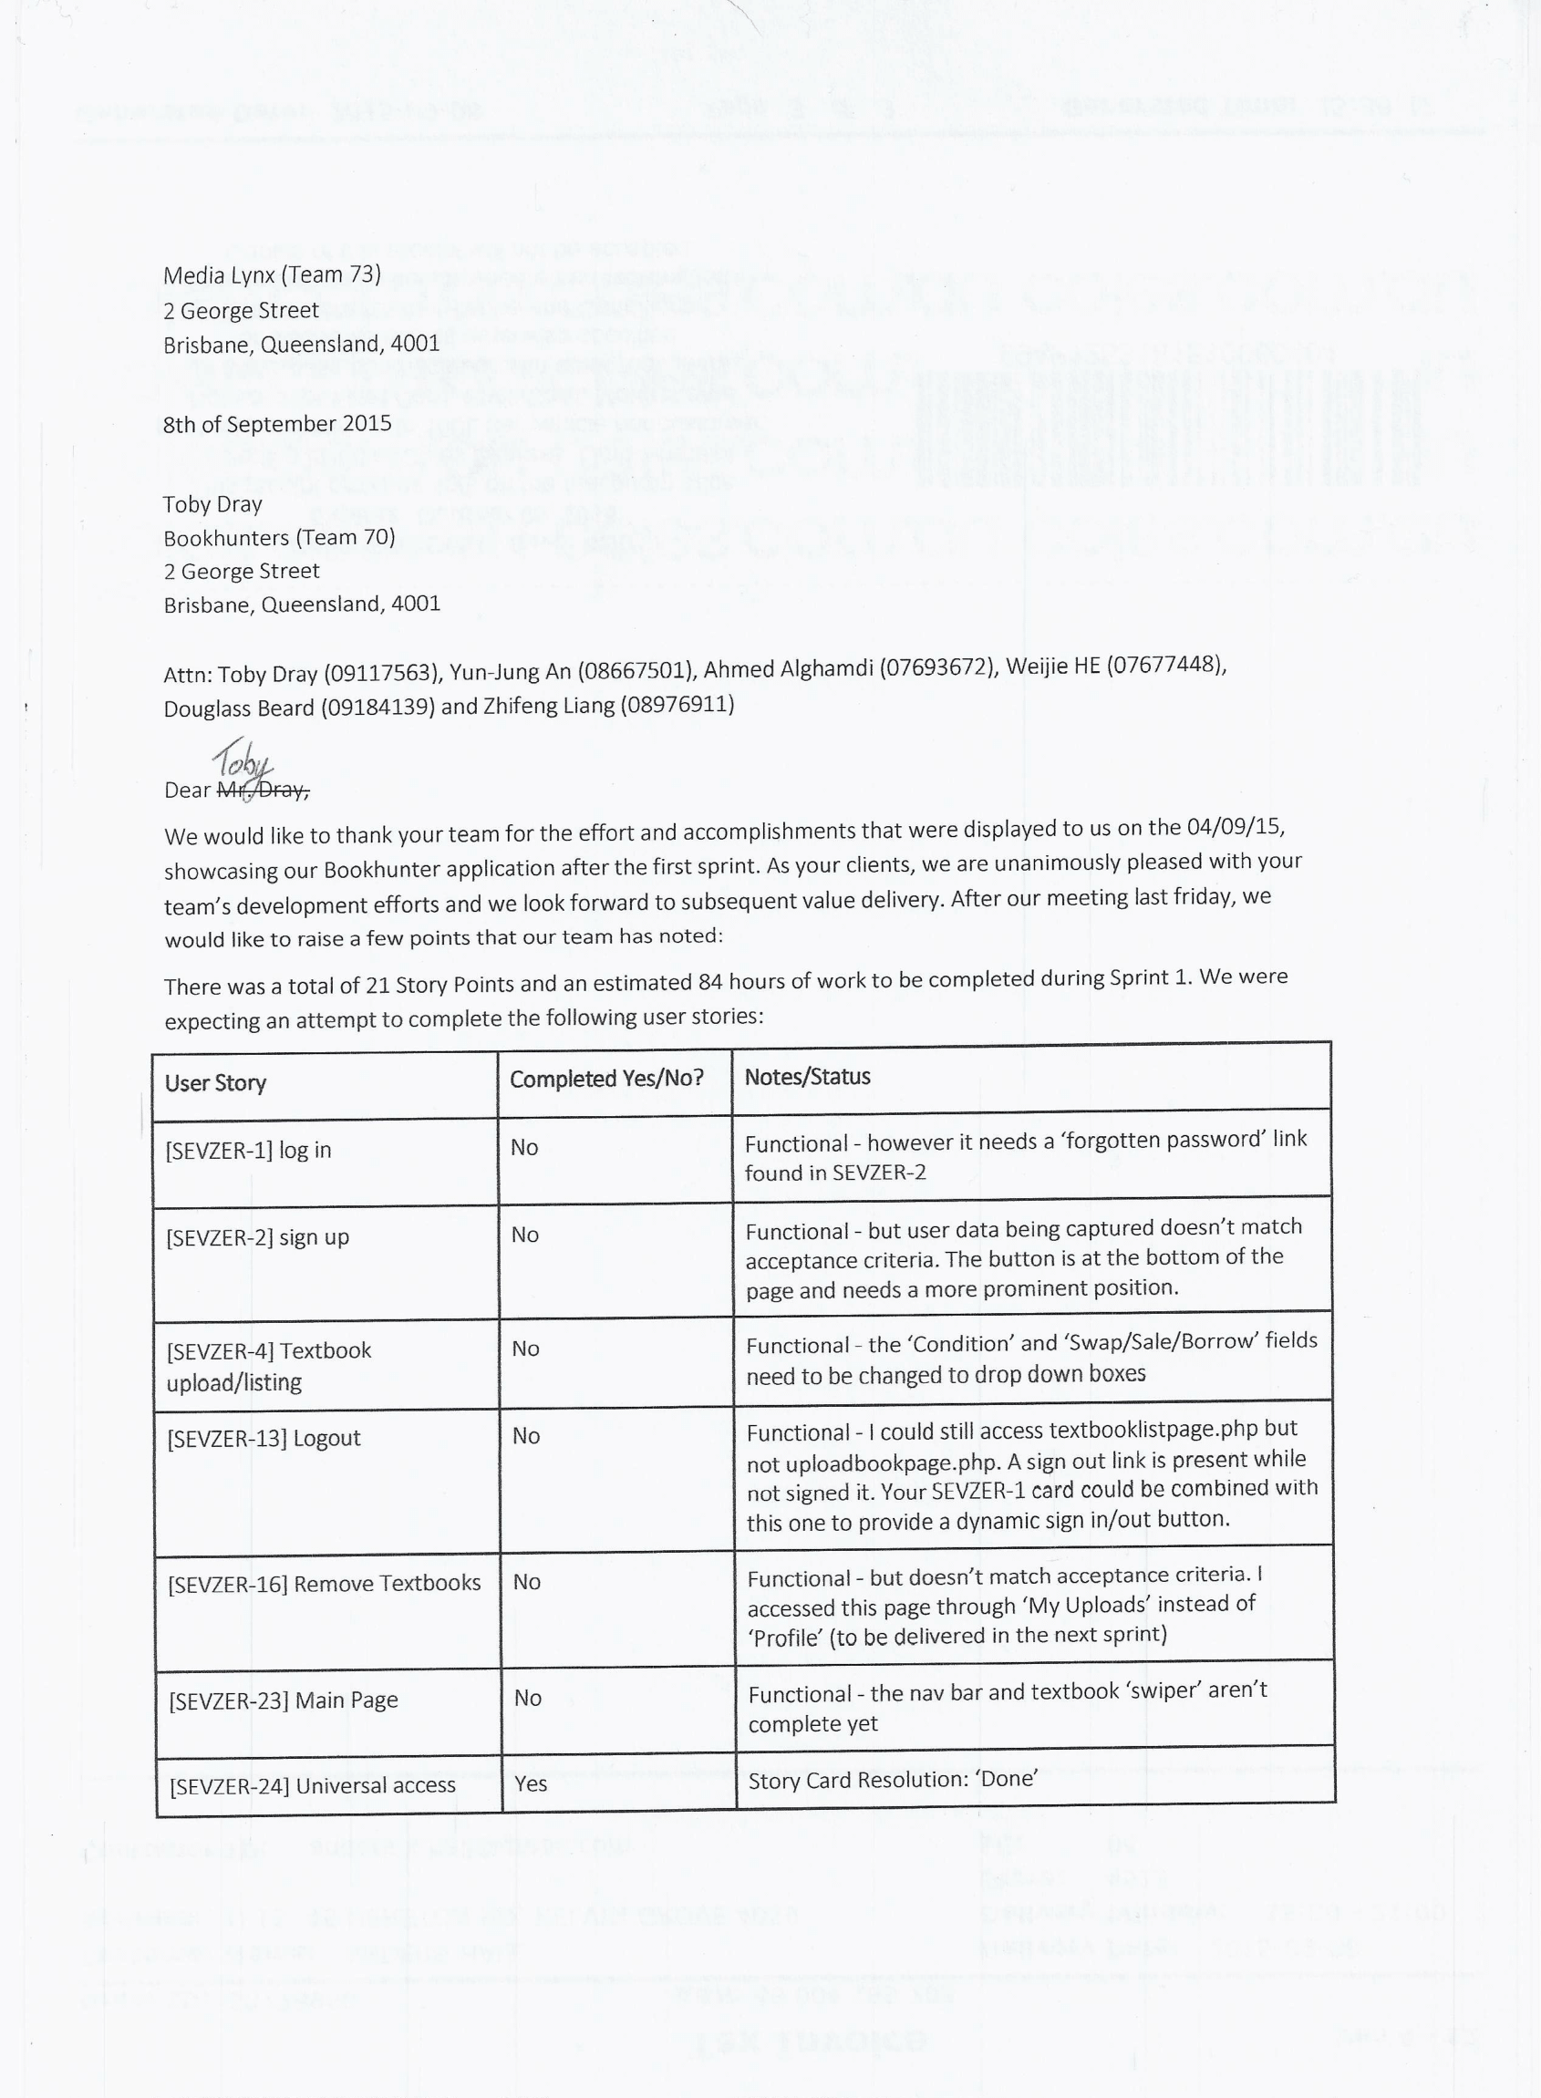

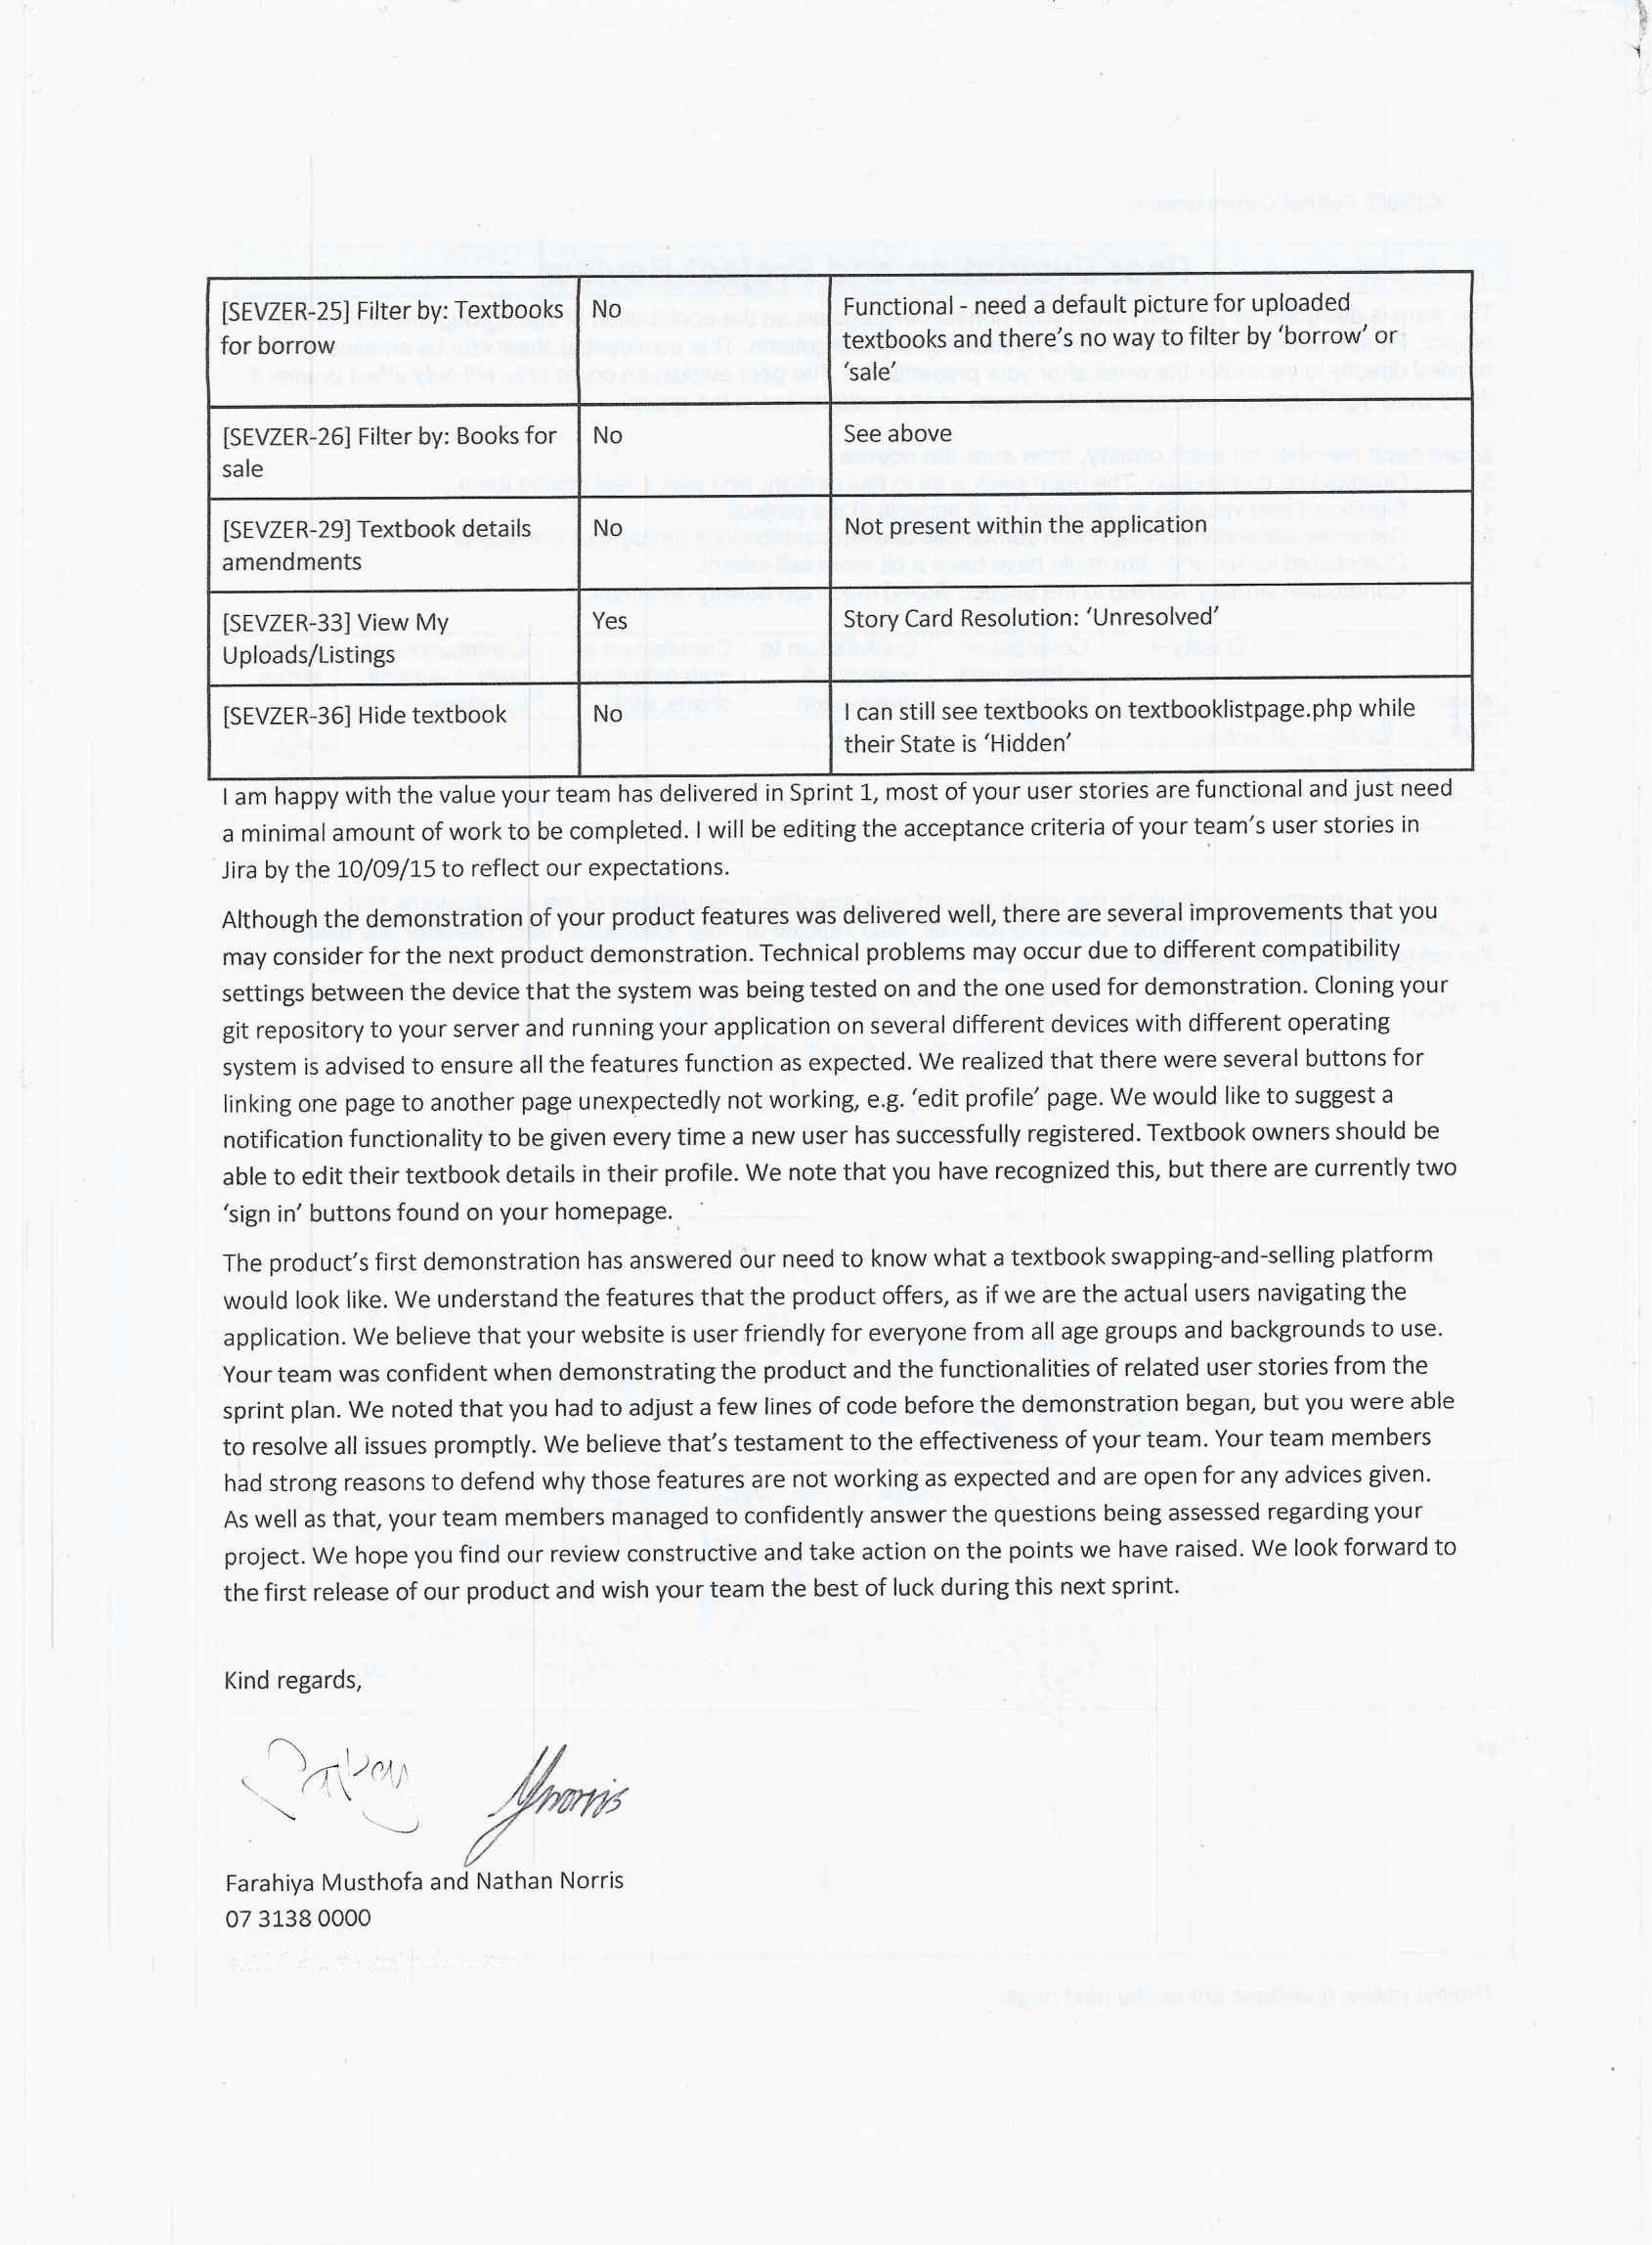

.

Based on the demonstration of the stories attempted by our developer team in the first sprint and the notes taken by all of my team members on the 04/09. Farahiya and I provided critical feedback in the form of a business letter addressed to our developer team contact, Toby Dray.

## Artefact 2

**Database Design and Development**

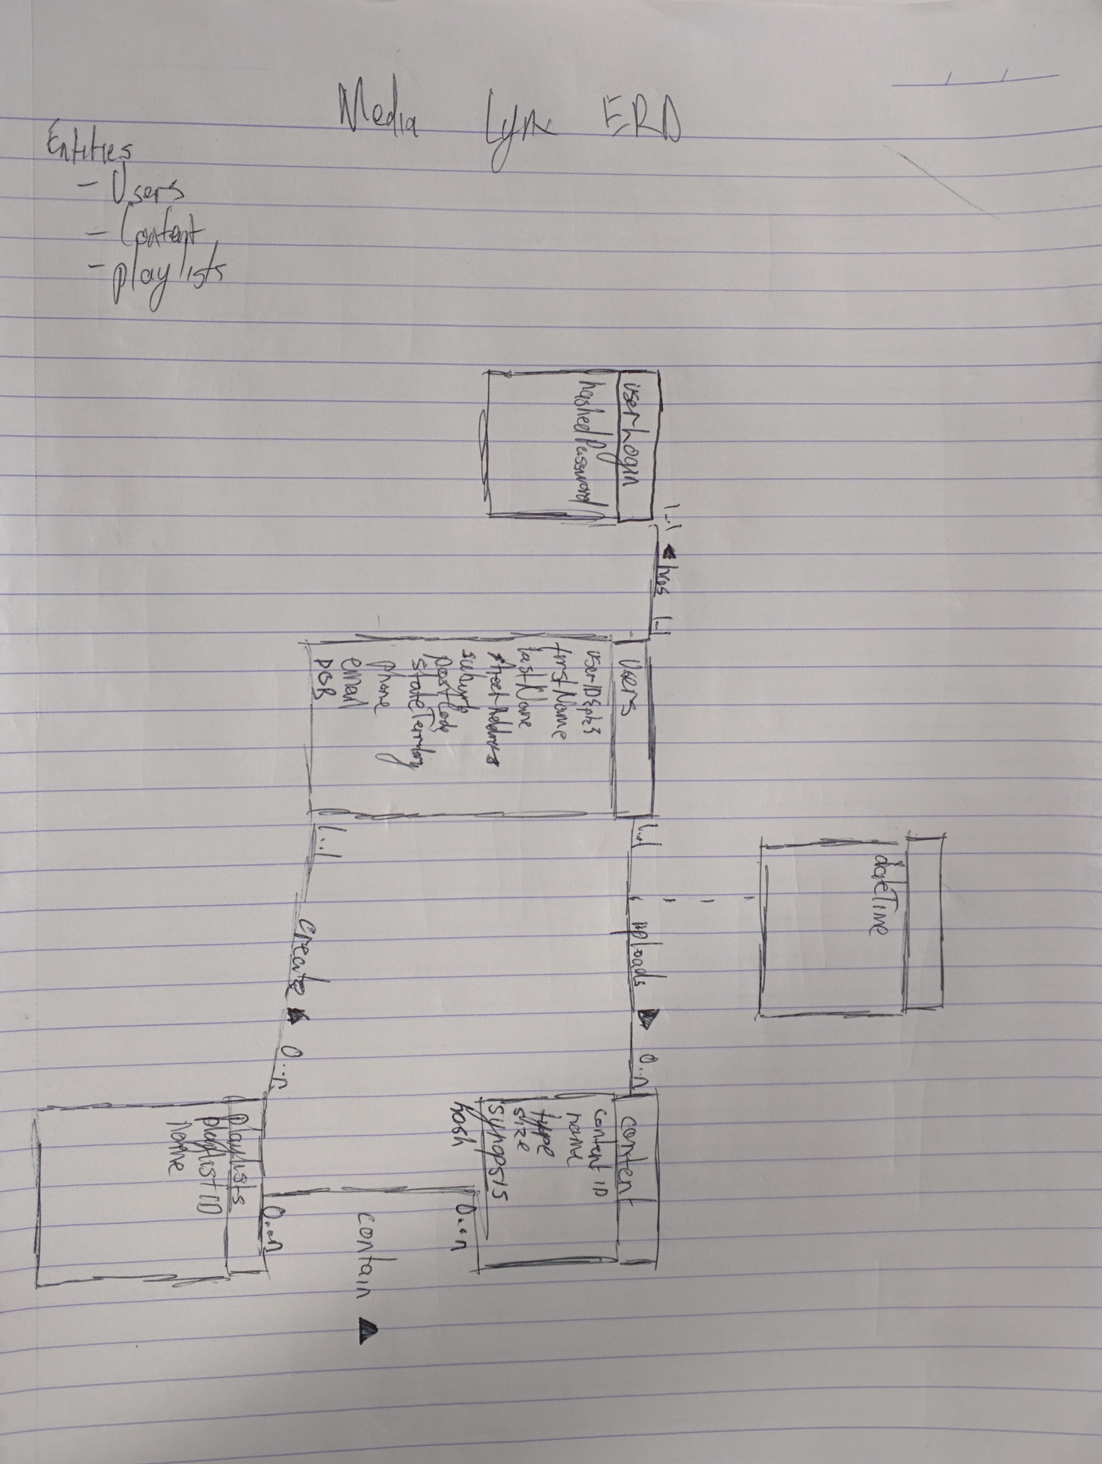

--

-- Database: `MEDIALYNX`

--

CREATE DATABASE IF NOT EXISTS `MEDIALYNX`

USE `MEDIALYNX`;

-- --------------------------------------------------------

--

-- Table structure for table `ACCESSTIME`

--

CREATE TABLE IF NOT EXISTS `ACCESSTIME` (

`CONTENTID` int(10) NOT NULL DEFAULT '0',

`LASTPLAYED` datetime NOT NULL,

PRIMARY KEY (`CONTENTID`)

) ENGINE=InnoDB DEFAULT CHARSET=utf8;

-- --------------------------------------------------------

--

-- Table structure for table `CONTENT`

--

CREATE TABLE IF NOT EXISTS `CONTENT` (

`USERID` int(10) DEFAULT NULL,

`CONTENTID` int(10) NOT NULL AUTO_INCREMENT,

`CONTENTTITLE` varchar(50) NOT NULL,

`CONTENTTYPE` varchar(20) NOT NULL,

`SIZE` decimal(10,0) NOT NULL,

`SYNOPSIS` varchar(500) NOT NULL,

PRIMARY KEY (`CONTENTID`),

KEY `FK_USERID` (`USERID`)

) ENGINE=InnoDB DEFAULT CHARSET=utf8 AUTO_INCREMENT=1 ;

-- --------------------------------------------------------

--

-- Table structure for table `PLAYLIST`

--

CREATE TABLE IF NOT EXISTS `PLAYLIST` (

`USERID` int(10) DEFAULT NULL,

`CONTENTID` int(10) DEFAULT NULL,

`PLAYLISTID` int(10) NOT NULL AUTO_INCREMENT,

`PLAYLISTNAME` varchar(60) NOT NULL,

PRIMARY KEY (`PLAYLISTID`),

KEY `FK_USERCONTENT` (`USERID`,`CONTENTID`)

) ENGINE=InnoDB DEFAULT CHARSET=utf8 AUTO_INCREMENT=1 ;

-- --------------------------------------------------------

--

-- Table structure for table `USERS`

--

CREATE TABLE IF NOT EXISTS `USERS` (

`USERID` int(10) NOT NULL AUTO_INCREMENT,

`FIRSTNAME` varchar(15) NOT NULL,

`LASTNAME` varchar(25) NOT NULL,

`EMAIL` varchar(60) NOT NULL,

`PASSWORD` varchar(20) NOT NULL,

`HASH` varchar(60) NOT NULL,

`SECRETQUESTION` varchar(60) NOT NULL,

`SECRETANSWERS` varchar(30) NOT NULL,

PRIMARY KEY (`USERID`)

) ENGINE=InnoDB DEFAULT CHARSET=utf8 AUTO_INCREMENT=1 ;

--

-- Constraints for table `ACCESSTIME`

--

ALTER TABLE `ACCESSTIME`

ADD CONSTRAINT `FK_CONTENTID` FOREIGN KEY (`CONTENTID`) REFERENCES `CONTENT` (`CONTENTID`);

--

-- Constraints for table `CONTENT`

--

ALTER TABLE `CONTENT`

ADD CONSTRAINT `FK_USERID` FOREIGN KEY (`USERID`) REFERENCES `USERS` (`USERID`);

--

-- Constraints for table `PLAYLIST`

--

ALTER TABLE `PLAYLIST`

ADD CONSTRAINT `FK_USERCONTENT` FOREIGN KEY (`USERID`, `CONTENTID`) REFERENCES `CONTENT` (`USERID`, `CONTENTID`);

In order for our application to work, we required a database to be implemented within the MySQL component of our LAMP stack. I started on a draft Entity-Relationship diagram which Farahiya completed in Visio. I then took the completed ERD and implemented the relations using SQL through the phpmyadmin portal of our server.

## Artefact 3

**Sprint Planning and Story Card Allocation**

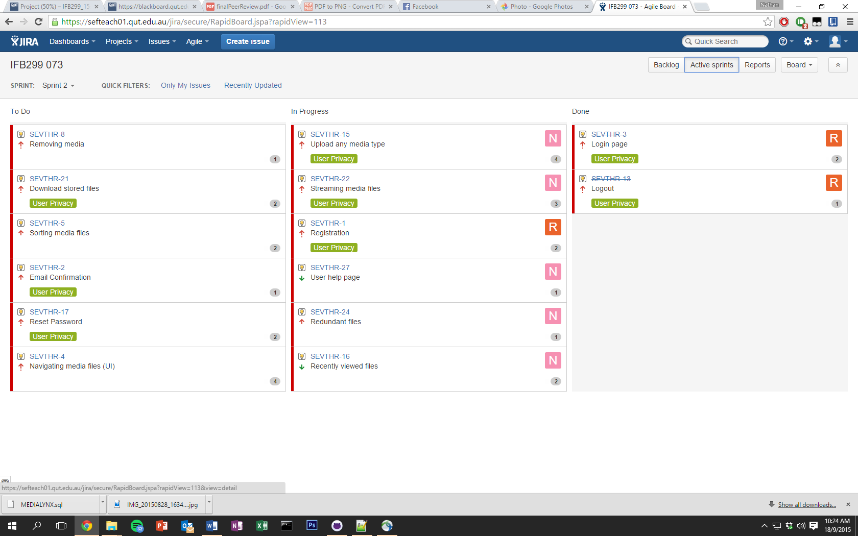

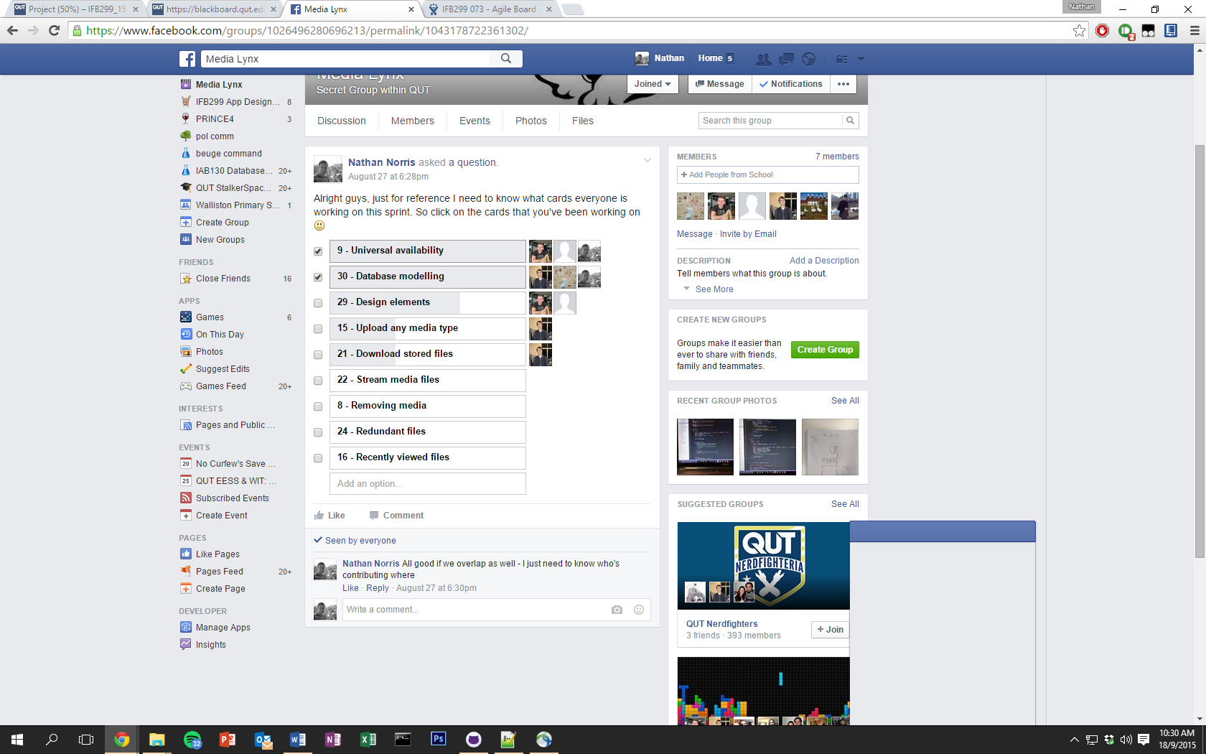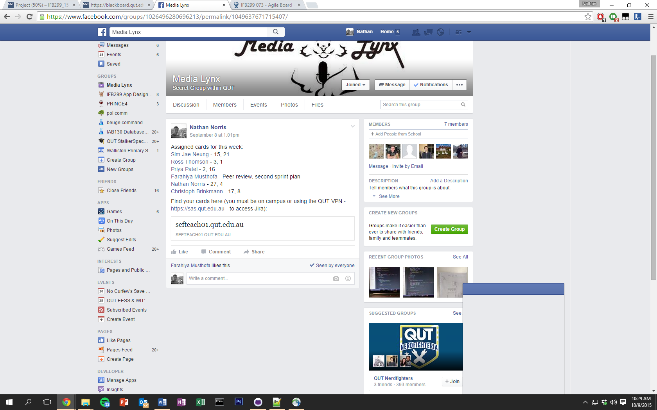

I led our team in discussions for what story cards would move into the sprint 1 and 2 backlogs. I tried to ensure that the cards that the CS students in my team were capable of completing the cards that I allocated for them. In the first sprint – I didn’t allocate cards to individuals as I expected the CS students to pick up cards when they had completed work. However, the majority of work completed in the first sprint was conducted by a minority of CS students. For the second sprint, I allocated and ensured that each CS student had work that they accepted. Poor project management by myself left some CS students with an unfair workload in the first sprint. I tried to rectify this in the second.

## Artefact 4

**‘Help’ page**

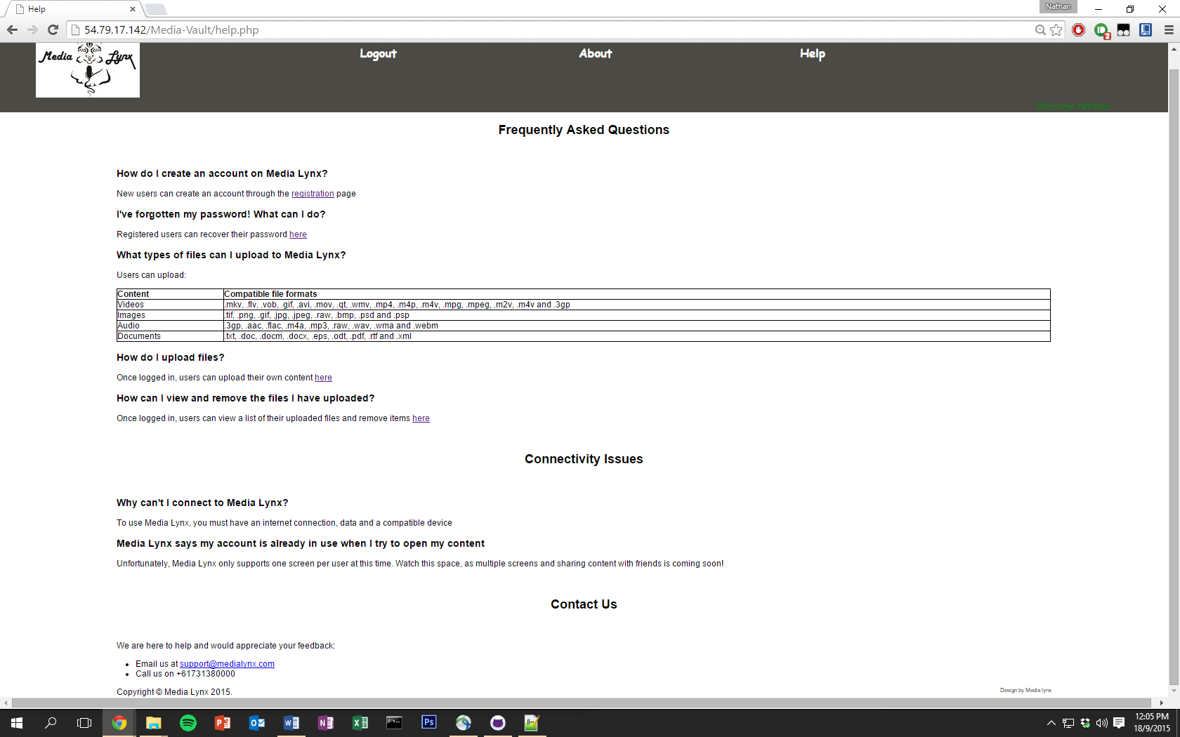

I edited the PHP and CSS relating to the ‘Help’ page of our application

## Artefact 5

**LAMP Stack Implementation**

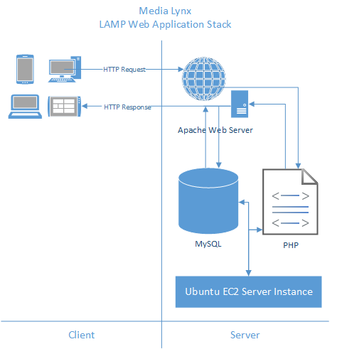

I led our team in creating the LAMP stack which we have used. I added my credit card details to the AWS account, installed each component on the EC2 server instance and ensured that every component of the stack was operational so that we could begin work at the start of our first sprint.